**ASSIGNMENT 12.1**

**-- Create Tables --**

CREATE TABLE HOTEL1 (

HOTEL_NO VARCHAR(5) PRIMARY KEY,

NAME VARCHAR(100),

ADDRESS VARCHAR(100)

);

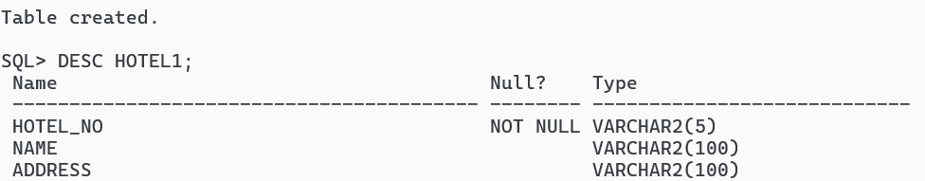

CREATE TABLE ROOM1 (

ROOM_NO VARCHAR(5) PRIMARY KEY,

HOTEL_NO VARCHAR(5) REFERENCES HOTEL1(HOTEL_NO),

TYPE VARCHAR(50),

PRICE DECIMAL(8, 2)

);

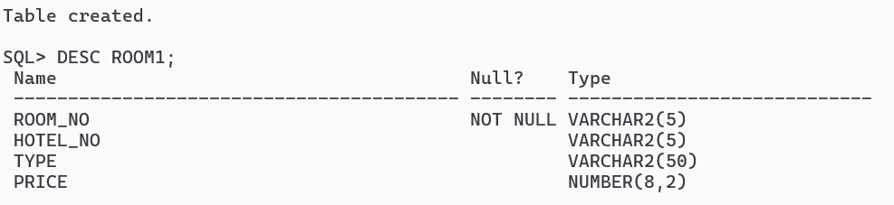

CREATE TABLE GUEST (

GUEST_NO VARCHAR(5) PRIMARY KEY,

NAME VARCHAR(100),

ADDRESS VARCHAR(100)

);

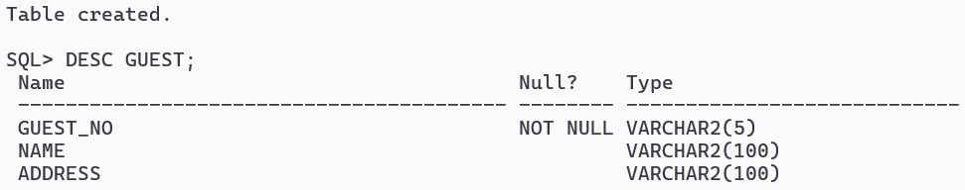

CREATE TABLE BOOKING1 (

HOTEL_NO VARCHAR(5) REFERENCES HOTEL1(HOTEL_NO),

GUEST_NO VARCHAR(5) REFERENCES GUEST(GUEST_NO),

DATE_FROM DATE,

DATE_TO DATE,

ROOM_NO VARCHAR(5) REFERENCES ROOM1(ROOM_NO)

);

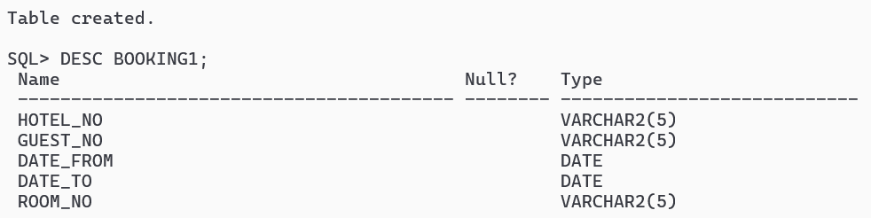

**-- Insert Data --**

INSERT INTO HOTEL1 VALUES('H1', 'GROSVENOR HOTEL', 'LONDON');

INSERT INTO HOTEL1 VALUES('H2', 'PARK HOTEL', 'NEW YORK');

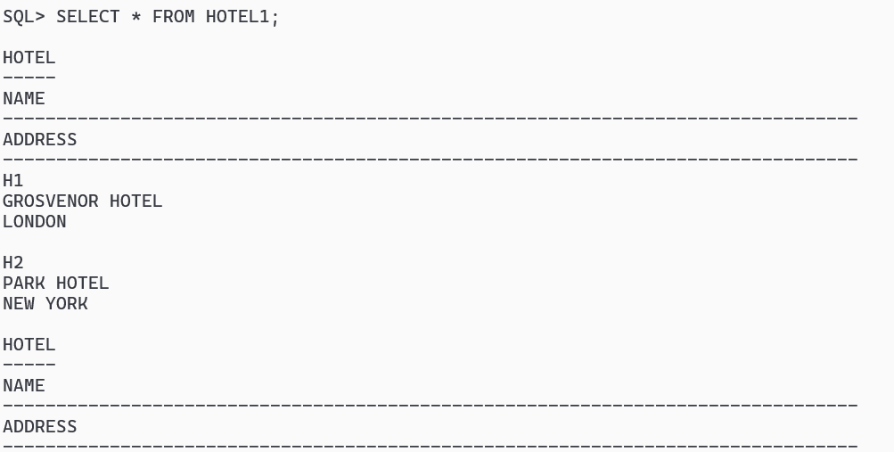

INSERT INTO ROOM1 VALUES('R11', 'H1', 'DOUBLE', 50.00);

INSERT INTO ROOM1 VALUES('R12', 'H1', 'DOUBLE', 60.00);

INSERT INTO ROOM1 VALUES('R13', 'H1', 'FAMILY', 80.00);

INSERT INTO ROOM1 VALUES('R21', 'H2', 'DOUBLE', 70.00);

INSERT INTO ROOM1 VALUES('R22', 'H2', 'DOUBLE', 75.00);

INSERT INTO ROOM1 VALUES('R23', 'H2', 'FAMILY', 100.00);

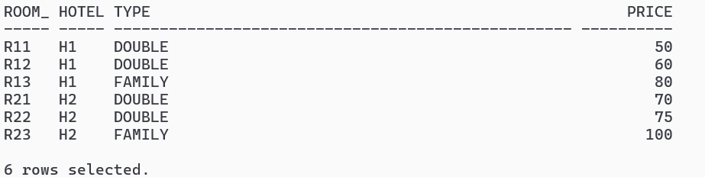

INSERT INTO GUEST VALUES('G1', 'JOHN SMITH', 'LONDON');

INSERT INTO GUEST VALUES('G2', 'EMMA JOHNSON', 'NEW YORK');

INSERT INTO GUEST VALUES('G3', 'MICHAEL BROWN', 'LONDON');

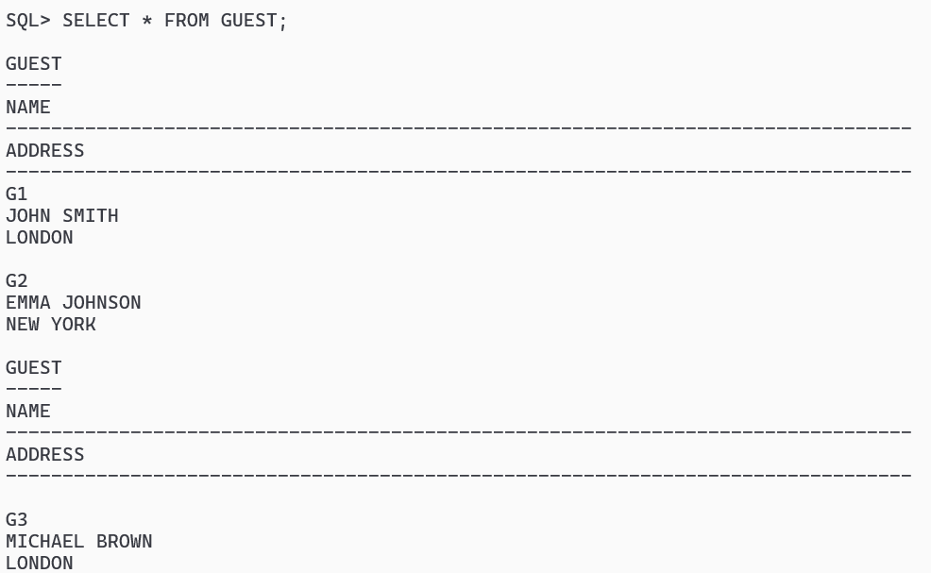

INSERT INTO BOOKING1 VALUES('H1', 'G1', '01-MAY-2024', '05-MAY-2025', 'R11');

INSERT INTO BOOKING1 VALUES('H1', 'G2', '01-JUN-2024', '05-JUN-2024', 'R13');

INSERT INTO BOOKING1 VALUES('H1', 'G3', '01-JULY-2024', 'NULL', 'R12');

INSERT INTO BOOKING1 VALUES('H2', 'G2', '10-MAY-2024', '15-MAY-2024', 'R21');

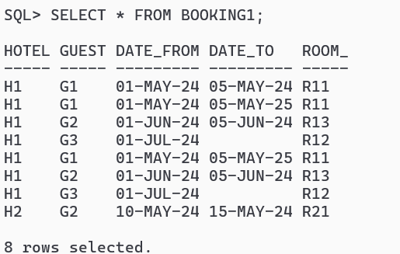

**-- Queries --**

**1. List the names and addresses of all guests in London, alphabetically ordered by name.**

SELECT NAME, ADDRESS

FROM GUEST

WHERE ADDRESS LIKE '%LONDON%'

ORDER BY NAME;

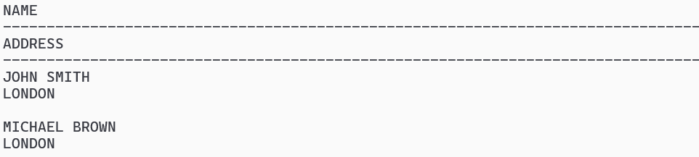

**2. List all double or family rooms with a price below £40.00 per night, in ascending order of price.**

SELECT *

FROM ROOM1

WHERE TYPE IN ('DOUBLE', 'FAMILY') AND PRICE < 40.00 ORDER BY PRICE ASC;

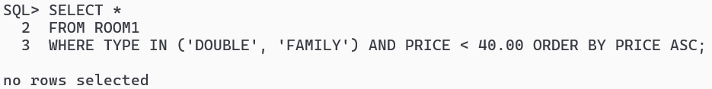

**3. List the bookings for which no date_to has been specified.**

SELECT *

FROM BOOKING1

WHERE DATE_TO IS NULL;

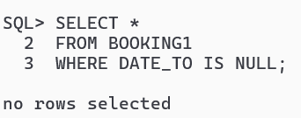

**4. How many hotels are there?**

SELECT COUNT(*) AS TOTAL_HOTELS FROM HOTEL1;

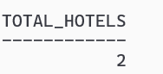

**5. What is the average price of a room?**

SELECT AVG(Price) AS AVERAGE_PRICE FROM ROOM1;

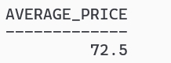

**6. What is the total revenue per night from all double rooms?**

SELECT SUM(Price) AS TOTAL_REVENUE FROM ROOM1 WHERE TYPE = 'DOUBLE';

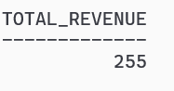

**7. How many different guests have made bookings for August?**

SELECT COUNT(DISTINCT GUEST_NO) AS TOTAL_GUESTS

FROM BOOKING1

WHERE EXTRACT(MONTH FROM DATE_FROM) = 8;

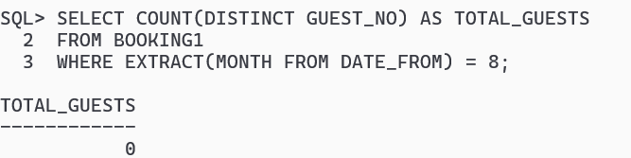

**8. List the details of all rooms at the Grosvenor Hotel, including the name of the guest staying in the room, if the room is occupied.**

SELECT R.*, G.NAME AS GUEST_NAME

FROM Room1 R

LEFT JOIN Booking1 B ON R.ROOM_NO = B.ROOM_NO

LEFT JOIN Guest G ON B.GUEST_NO = G.GUEST_NO

WHERE R.HOTEL_NO = 'H1';

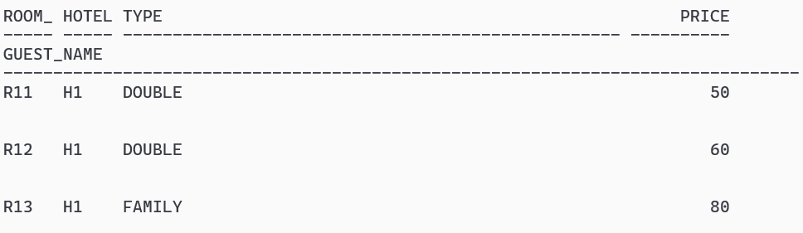

**9. What is the total income from bookings for the Grosvenor Hotel today?**

SELECT SUM(R.PRICE) AS TOTAL_INCOME

FROM ROOM1 R

JOIN BOOKING1 B ON R.ROOM_NO = B.ROOM_NO

WHERE B.HOTEL_NO = 'H1' AND B.DATE_FROM = CURRENT_DATE;

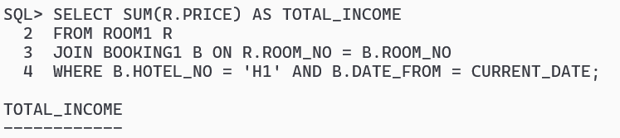

**10. List the rooms that are currently unoccupied at the Grosvenor Hotel.**

SELECT *

FROM ROOM1

WHERE HOTEL_NO = 'H1' AND ROOM_NO NOT IN (SELECT ROOM_NO FROM BOOKING1 WHERE HOTEL_NO = 'H1');

